Please Print Out This Form, Sign & Submit w/ your Team Application

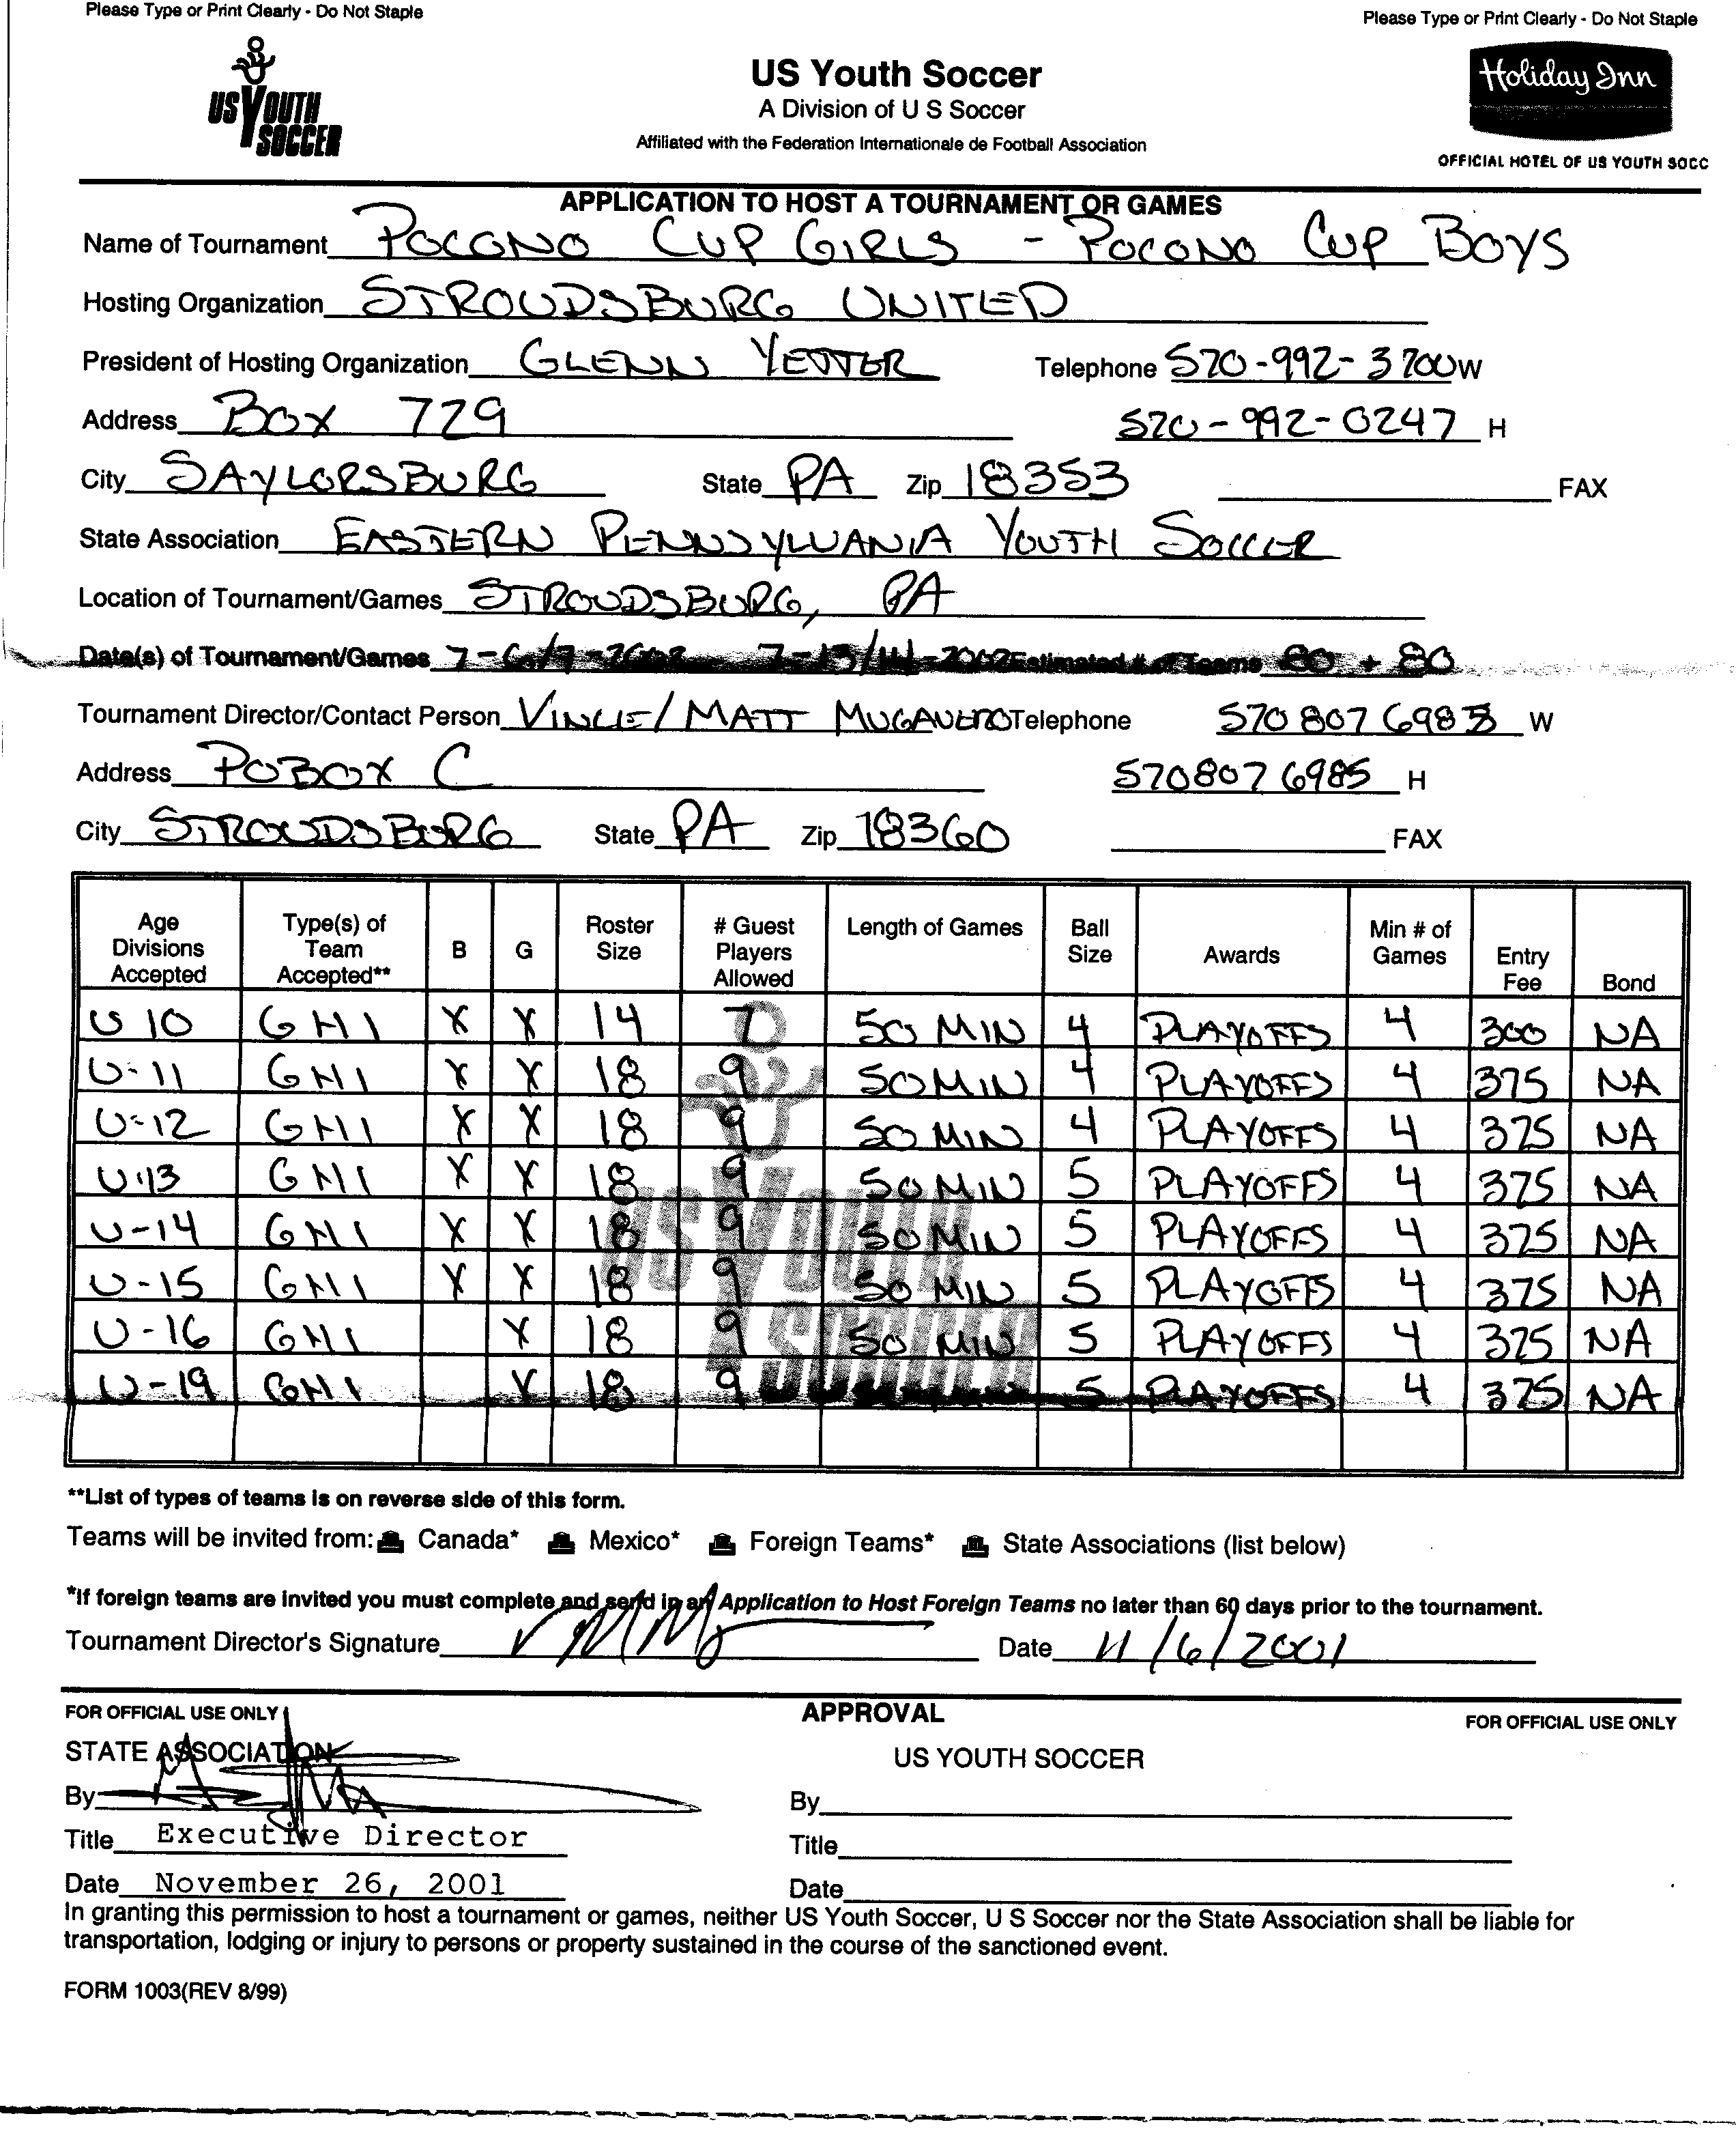
Girls July 6-7, 2002 Boys July 13-14, 2002

